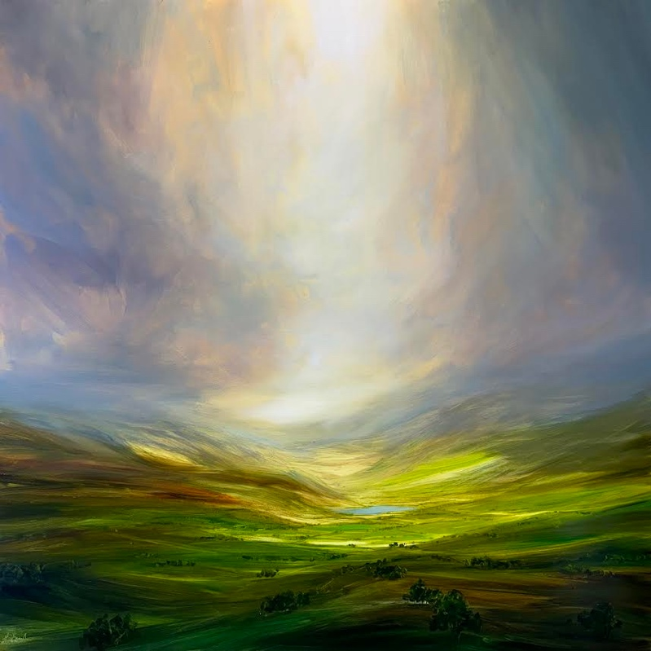

PRESS RELEASE
Hashim Akib
Harry Brioche
‘Town and Country’
Opens 30th April 2024

Thompson’s Gallery, Aldeburgh are holding an exhibition by two of our most favoured artists; Hashim Akib and Harry Brioche. Although contrasting in style we think that they ultimately compliment each other and will show a fantastic representation of townscapes and landscapes.

Hashim Akib uses heavy body acrylics to support his expressive brush strokes and creates a textural paint finish to bring depth to his urban scenes “The fast drying properties of acrylics means paintings can be completed relatively quickly and as my style is expressive the momentum behind the process is very important. Practically all my contemporaries at college were using oils so I bagged acrylic to be different”. As well as painting, Hashim performs painting demonstrations and teaches classes as well as being a regular contributor to Artists & Illustrated.

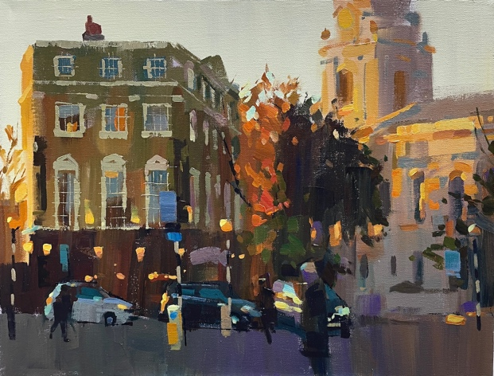
Harry Brioche was born in the Seychelles in 1965 or Creole and American parentage. He had a wonderful childhood growing up on the Island of Mahe but after 1977 found himself settled with his family in Manchester. Harry did attend Maidstone College of Art but still considers himself a self-taught artist. From an early age Harry was captivated by the drama and beauty of the British sky and landscape. The ever-changing weather patterns and atmospheric condition were in stark contrast to the tropical idyll of the Seychelles. This inspiration continues to be ever present in his paintings. It is this atmosphere and mood created by the light which is his inspiration and which he portrays so well in his paintings, showing the spirit of the landscape.
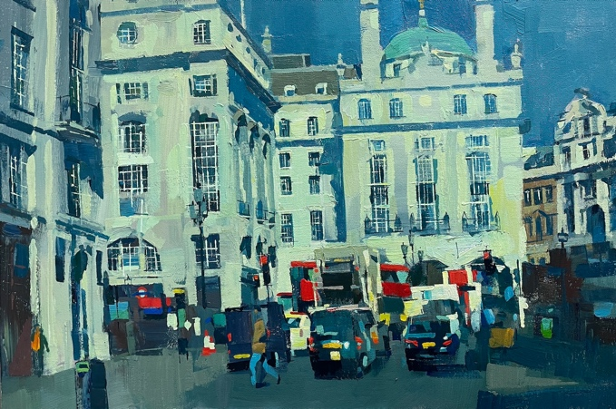

For further information or to request higher resolution images please contact: Camilla McCausland, Thompson’s Gallery, 175 High Street, Aldeburgh, Suffolk, IP15 5AN Tel. 01728 453743 email. camilla@thompsonsongallery.co.uk

