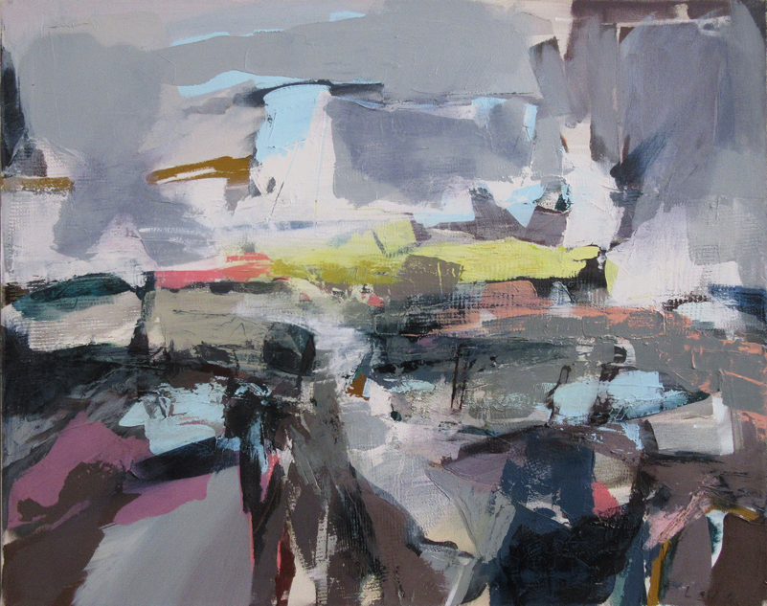

PRESS RELEASE
41st Annual Exhibiton
Opens 10th June 2023

Thompson’s Gallery, Aldeburgh are proud to be holding our Annual Exhibition which is our 41st year of this tradition. It is the most exciting time of the year for us when we show selected work from our large stable of artists, some of whom we have been representing throughout that time and those who have been added over the years and then of course there are new artists who we have carefully selected to join us. Thompson’s Gallery has a strong tradition of showing work of the highest quality and are careful to show only the best of what British art has to offer. As in the past we have examples of work from the 20th Century as well as the 21st Century and are pleased to be able to show works by Mary Fedden, Kyffin Williams, John Piper, Henry Moore and Alan Davie. All are typical works of each artist and of great quality and representation. On the more contemporary side we are showing a good selection of Scottish artists amongst them Jonathan Robertson, James Harrigan, Joe Hargan, Jenny Matthews (who trained under Elizabeth Blackadder), Judith Bridgland and Ronald Smith. We have also included works by artists from south of the border which include Nick Grove, Emma Williams, Bruce Yardley, Tessa Newcomb, Ania Hobson, Angela A’Court, Hashim Akib, Jo Tayalor, Jeanette Hayes and Ben Lowe. There will be a broad spectrum of media and style, figurative and abstract which shows the enthusiasm we have for showing something for everyone. We are also showing a selection of South African artists and included in this group are Rene Snyman and Pieter Krugel. Both use different media to express different aspects of their country and culture.
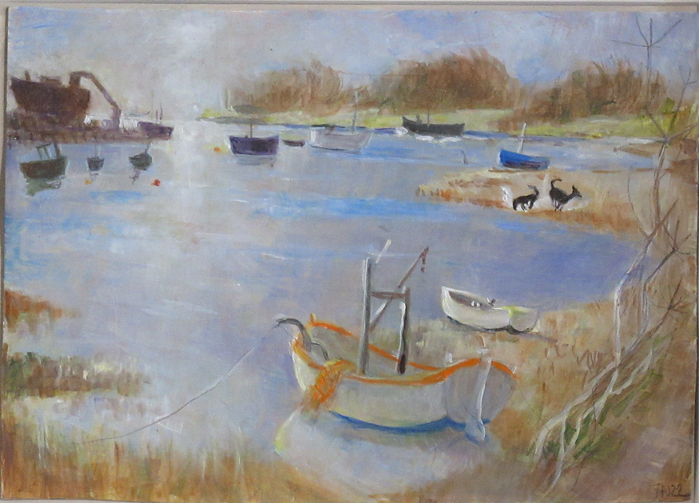
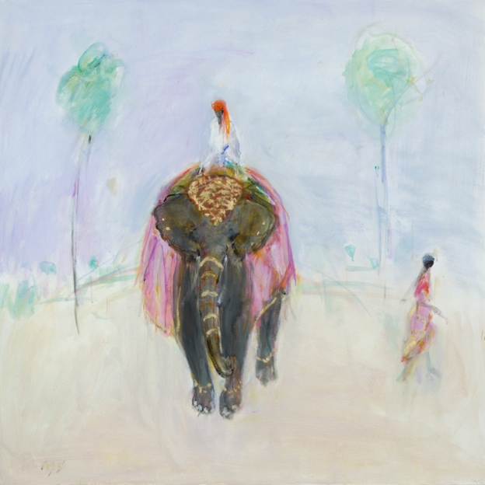

For further information or to request higher resolution images please contact: Camilla McCausland, Thompson’s Gallery, 175 High Street, Aldeburgh, Suffolk, IP15 5AN Tel. 01728 453743 email. camilla@thompsonsongallery.co.uk

