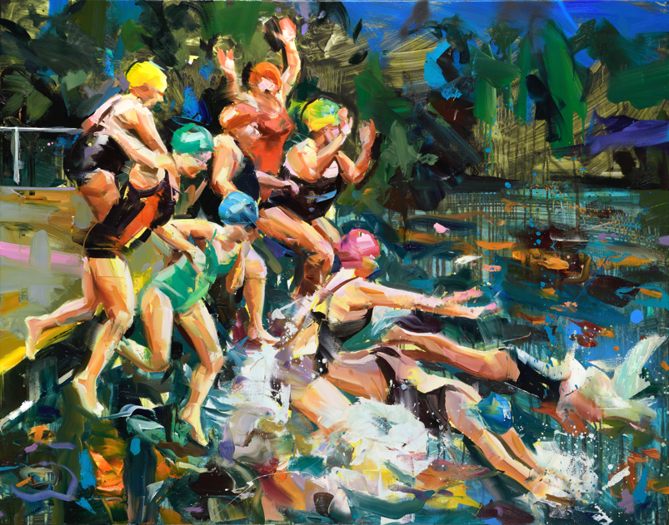

PRESS RELEASE
PAUL WRIGHT
A Milestone
Opens 8th July 2023

Thompson’s Gallery, Aldeburgh will be holding a solo exhibition by the hugely talented artist Paul Wright. His bold and strong brushstrokes invites an element of freedom and his work is uplifiting and liberating. He is a hugely talented painter and uses every day scenes and objects as inspiration. His preferred medium to work in is oil and he uses this lavishly on the canvases using bold colours to portray his chosen composition, some figurative and some bordering on the semi abstract but all with the easily recognisable thick brush strokes he cleverly crafts to achieve what he sets out to do. He has been shortlisted twice for the National Portrait Gallery BP Award in 2006 and 2015 and combines his highly observational portraits with thoughtful landscapes and interiors.

“For the first time in many years I have had the opportunity to develop a body of work over a period of time that has allowed me to show the full range of my artistic interests over the last two decades. This exhibition of new unseen paintings also arrives to coincide with my 50th birthday and nearly 20 years of exhibiting with Thompson’s Gallery both in London and Aldeburgh. At this point in my career, it is obvious to me that I place each of the subjects of my work so that I can better test my technique and skills of interpretation. Revisiting older subjects such as shoes and chairs has also illustrated the development that my technique has undergone alongside the methods in which I can best convey these subjects. The subjects often relate to activities in my world, the series of swimmers are a direct result of sitting next to pools watching my daughter May swim for her club and likewise the dancers came about because of May’s interest in dance and watching the annual dance school shows that include ballet and tap. Physically the paintings are now made from layers of paint, often transparent oil paint and then move towards more thickly applied areas. Vibrant colour and an expressive use of mark making has been an ever present in my work and continues to give the subject energy and presence in this collection.”
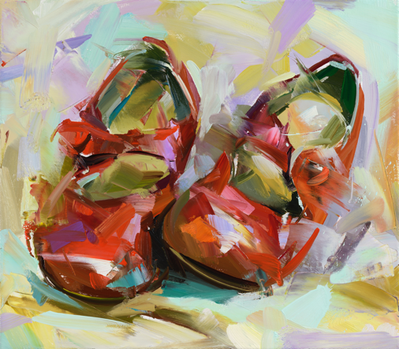
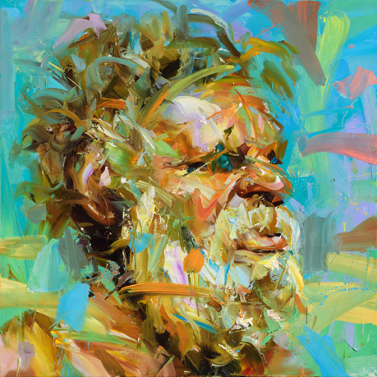
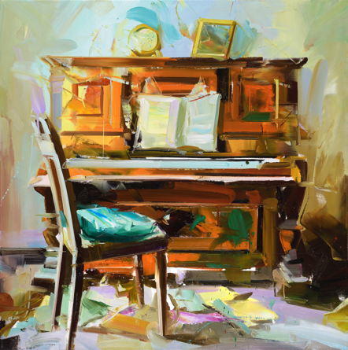

For further information or to request higher resolution images please contact: Camilla McCausland, Thompson’s Gallery, 175 High Street, Aldeburgh, Suffolk, IP15 5AN Tel. 01728 453743 email. camilla@thompsonsongallery.co.uk

