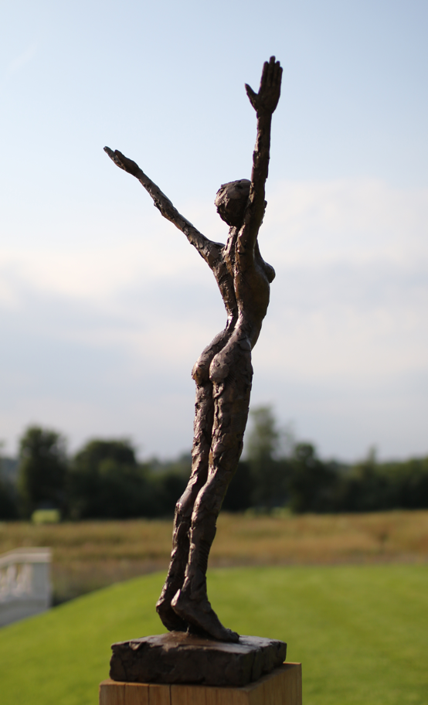

PRESS RELEASE
Works by Carol Peace and
Launch of new Sculpture
Garden in Aldeburgh
29th July 2023

Thompson’s Gallery, Aldeburgh are celebrating the opening of their new sculpture garden with a solo show by the sculptor Carol Peace. This will be an opportunity to see her new work but also to see the fabulous new sculpture garden that has been created to show sculpture at its best outside as well as inside the gallery. The sculpture garden has been carefully planned over the last year to show off the pieces at their best and we feel there is no better sculpture to show this than work by Carol Peace who we have been showing for many years now and whose ethereal pieces often have strong female representation and are incredibly popular with our clients. They each carry a strong message of peace, serenity and love but also a sense of togetherness and strength. Carol trained at Winchester School of Art and has forged a very successful career ever since. She is constantly challenging herself to come up with new ideas and techniques although she would state that she could not work without drawing; the process of drawing and the intuitive response is what she aims for in her work. After graduating she set up the Bristol Sculpture Shed, later known as Spike Island, and following that moved to her Paintworks studio in Bristol in 2004 and finally ending up in her studio on East London where she has been since 2019 whilst also having a studio in Wales for larger pieces. Her intensely personal work is shown and collected all over the UK, Europe, the Far East and the United States and her large scale work are on permanent show at Glyndebourne and in Ascot. The sculptures are made in clay and once finished they are cast into bronze. “The work is about everyday life, in its minutia, the sheer fantastic-ness of it all, they are first of all real people”.

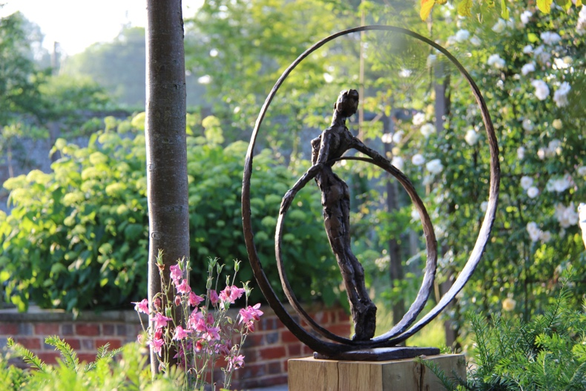
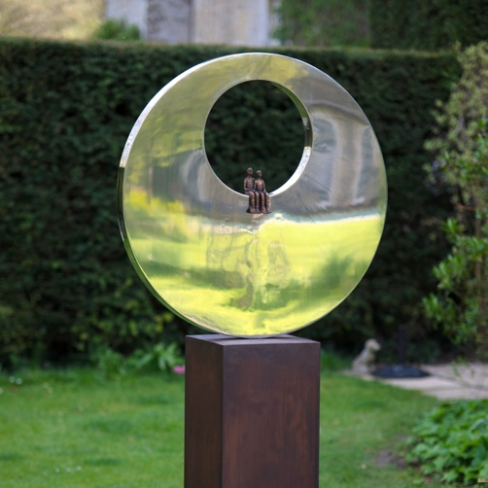

For further information or to request higher resolution images please contact: Camilla McCausland, Thompson’s Gallery, 175 High Street, Aldeburgh, Suffolk, IP15 5AN Tel. 01728 453743 email. camilla@thompsonsongallery.co.uk

